1.D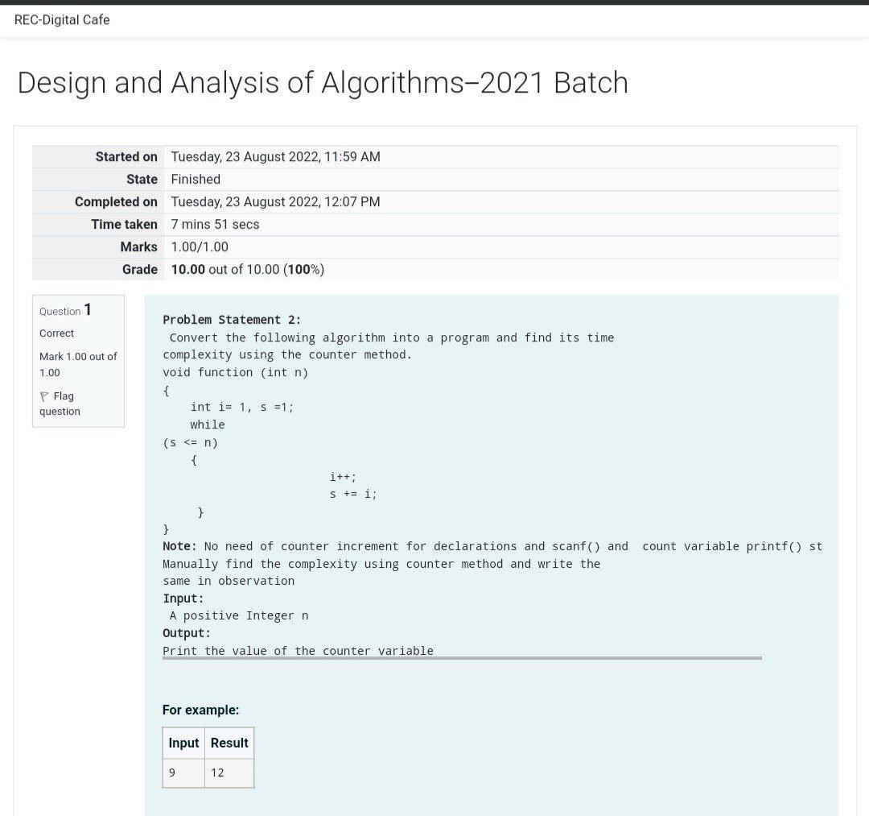

PROGRAM:

#include <stdio.h> void function(int min); int main()

{

int n; scanf(“%d”,&n); function(n); return 0;

}

void function(int n)

{

int count=0; int i=1,s=1; count++; count++; while(s<=n)

{

count++; i++;

count++; s+=i; count++;

}

count++; printf(“%d”,count);

}

OUTPUT:

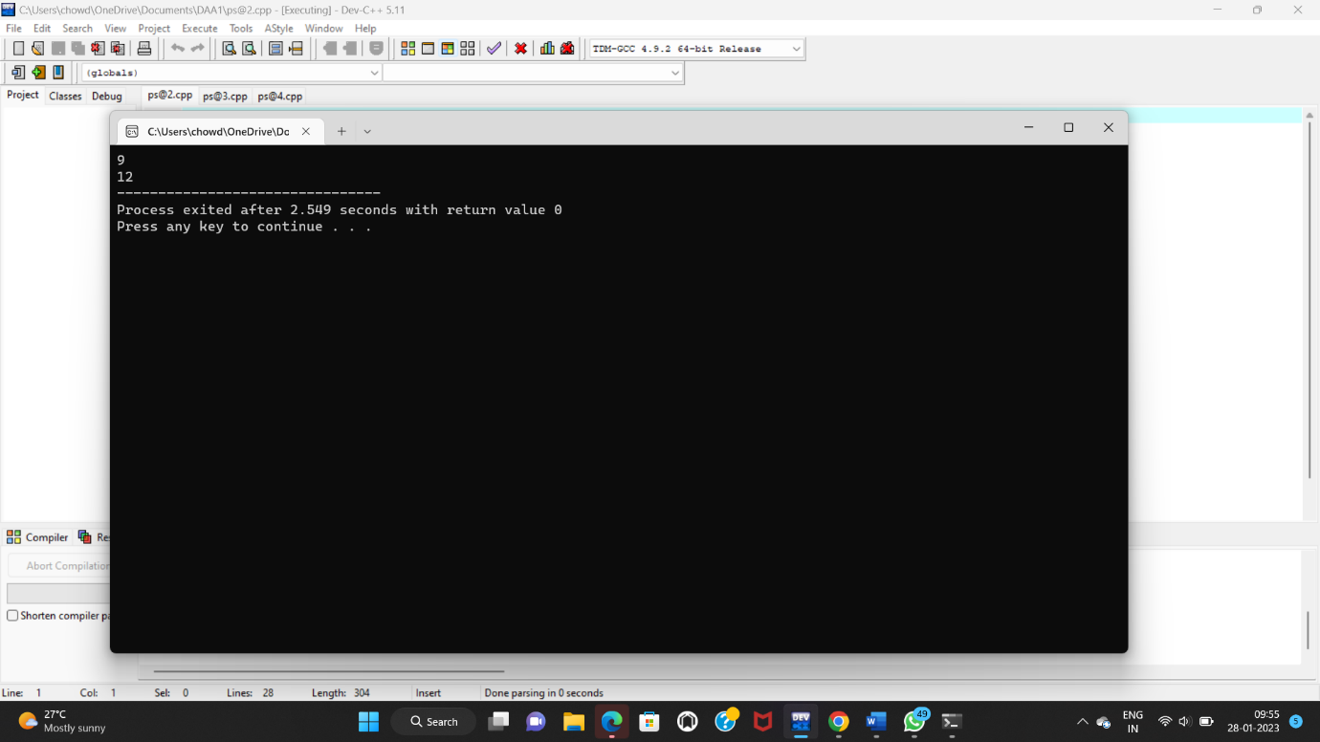

2. 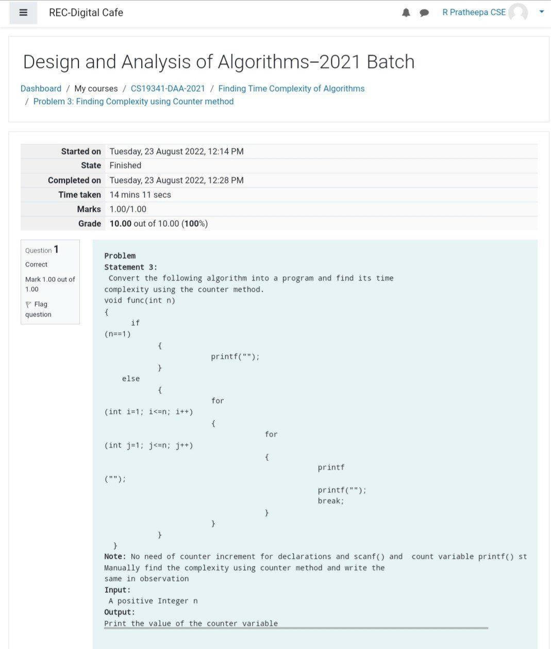

PROGRAM:

#include <stdio.h> void function(int n); int main()

{

int n; scanf("%d",&n); function(n); return 0;

}

void function(int n)

{

int count=0; if(n==1)

{

count++; count++;

}

else

{

count++;

for(int i=1;i<=n;i++)

{

count++;

for(int j=1;j<=n;j++)

{  
count++;

count++:

count++;

count++:

break;

}

}count++;

}

Printf(“%d”,count);

}

OUTPUT:

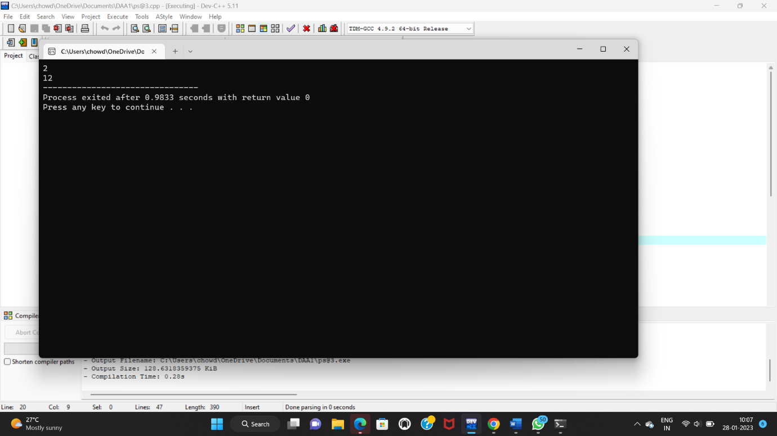

3.

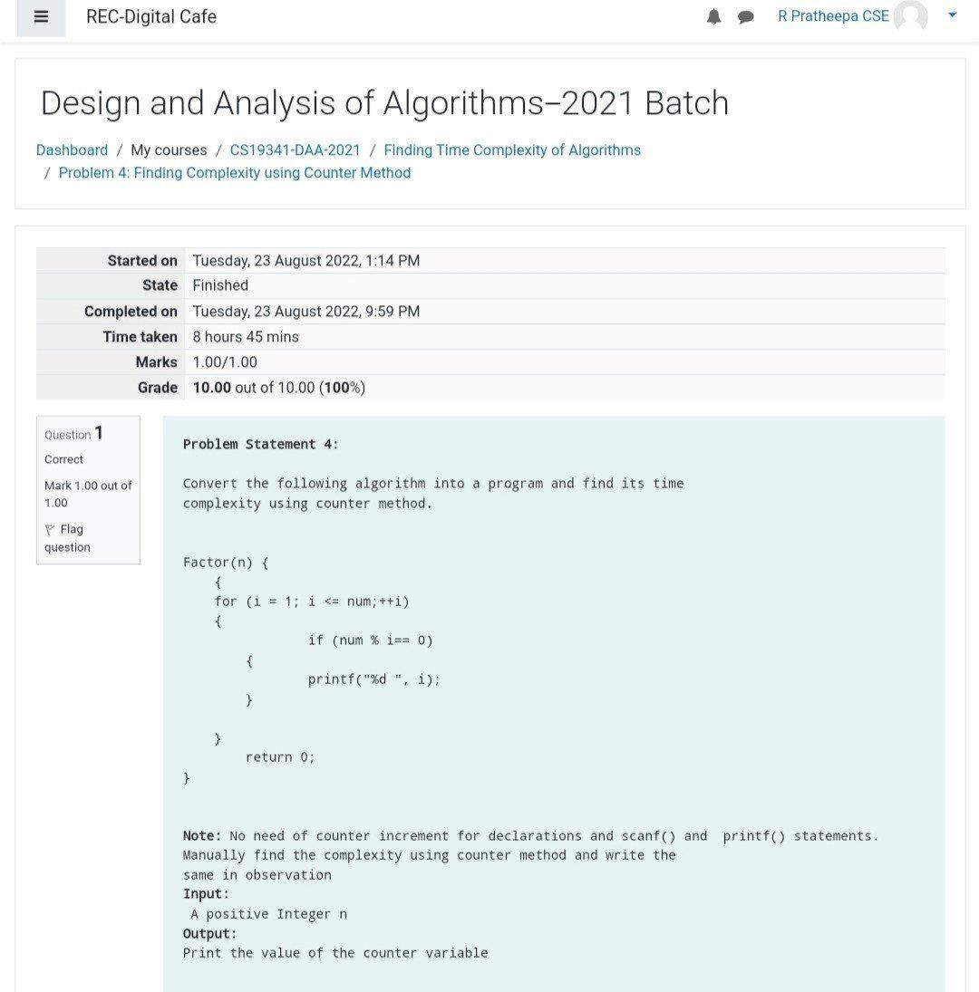

PROGRAM:

#include <stdio.h>

int factor(int n);

int count=0;

int main()

{

int n;

scanf("%d",&n);

factor(n);

printf("%d",count);

return 0;

}

int factor(int n)

{

int i; count++;

for(i=1;i<=n;++i)

{

count++;

if(n%i==0)

{

//print

}count++;

}

count++; return 0;

}

OUTPUT:

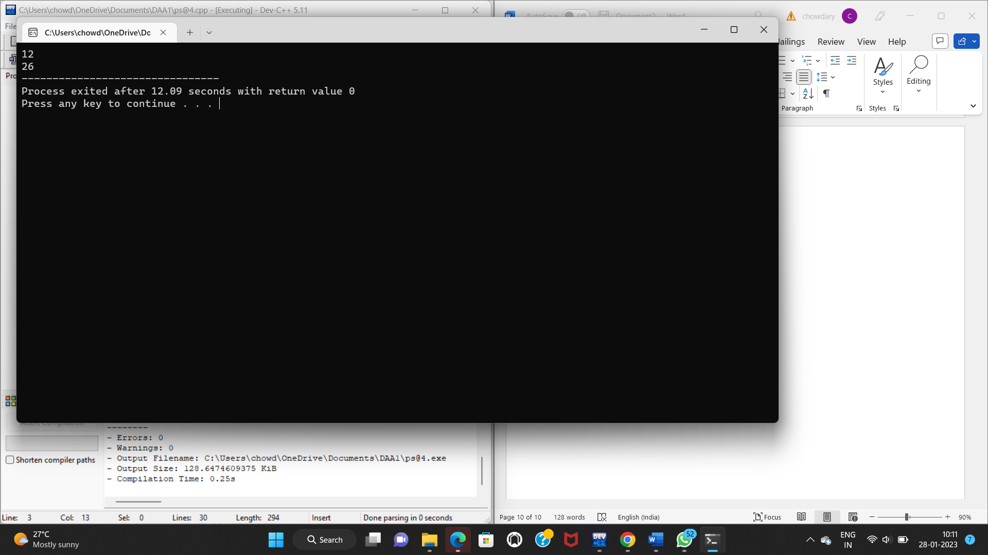

4.

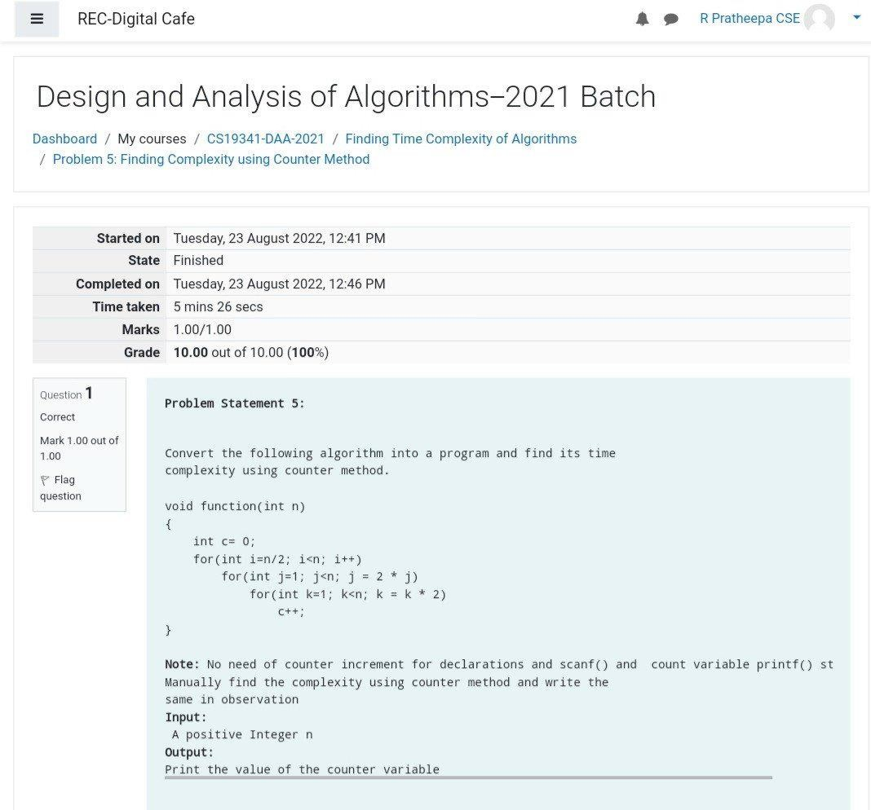

PROGRAM:

#include <stdio.h>

void function(int n);

int main()

{

int n;

scanf("%d",&n);

function(n);

return 0;

}

void function(int n)

{

int count=0;

int c=0;

count++;

for(int i=n/2;i<n;i++)

{

count++;

for(int j=1;j<n;j=2\*j)

{

count++;

for(int k=1;k<n;k=k\*2)

{

count++;

c++;

count++;

}count++;

}count++;

}count++;

printf("%d",count);

}

OUTPUT:

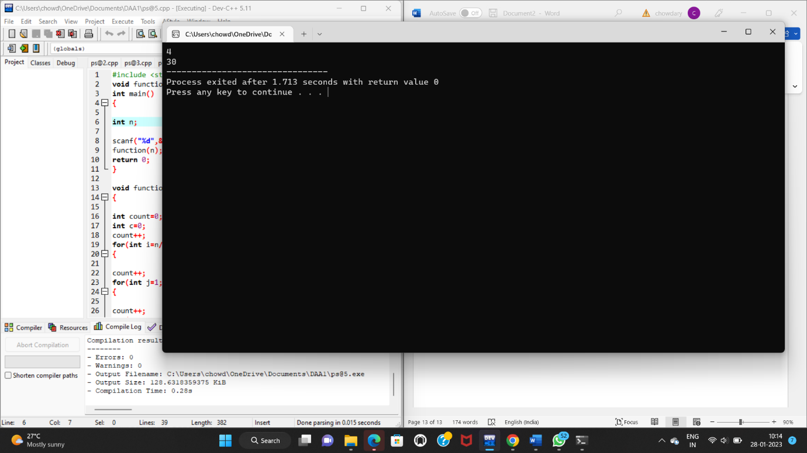

5.

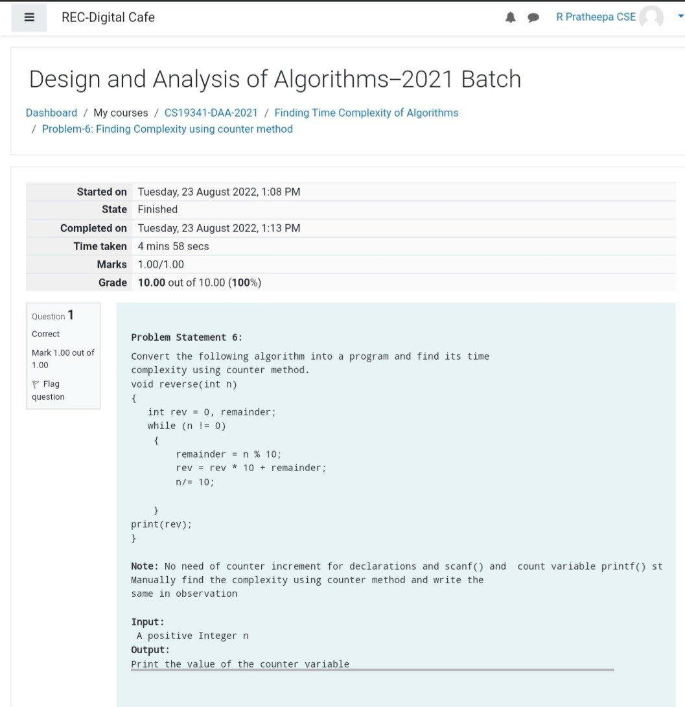

PROGRAM:

#include <stdio.h>

void reverse(int n);

int main()

{

int n;

scanf("%d",&n);

reverse(n);

return 0;

}

void reverse(int n)

{

int count=0;

int rev=0,remainder;

count++;

while(n!=0)

{

count++;

remainder=n%10;

count++;

rev=rev\*10+remainder;

count++;

n=n/10;

count++;

}

count++;

count++;

printf("%d",count);

}

OUTPUT:

